WEEK-2

AIM: Installation of XAMPP Local-Server for Back-end support.

THEORY:
2.1: Installation Steps (XAMPP)
STEP-1:
Open the Terminal
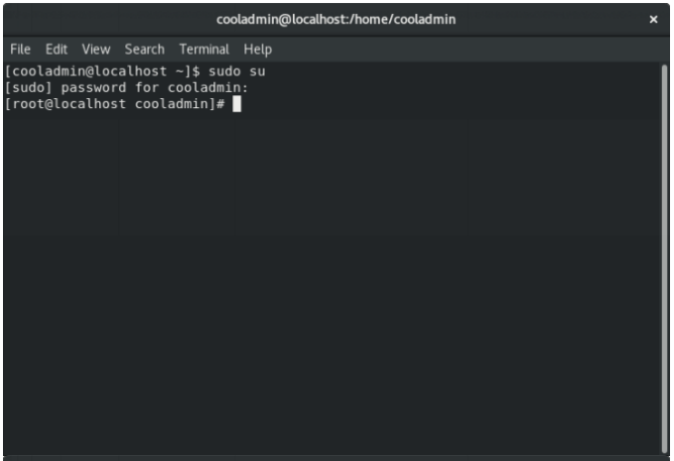

STEP 2:
Download the latest version of Xampp
Open up terminal and run the following commands
Download the latest version according to your system.
wget https://sourceforge.net/projects/xampp/files/latest/download
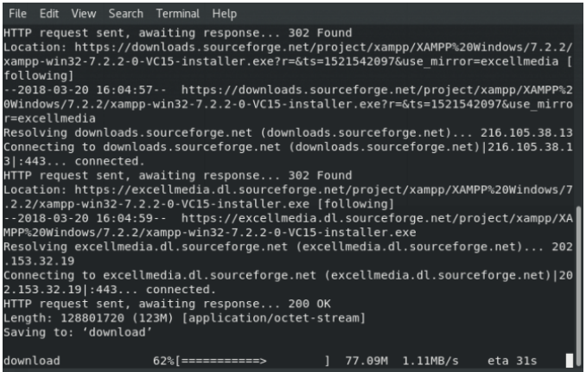

STEP 3:
Change the downloaded files permission to an executable and run the file
sudo chmod +x xampp-linux-x64-1.8.3-2-installer.run
sudo ./xampp-linux-x64-1.8.3-2-installer.run
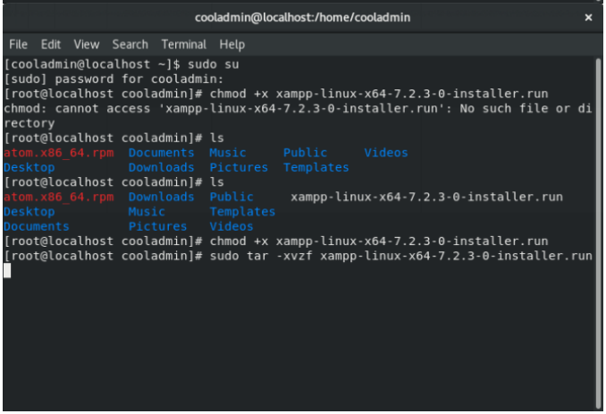
STEP-4:
An installation wizard will run. Complete the installation.
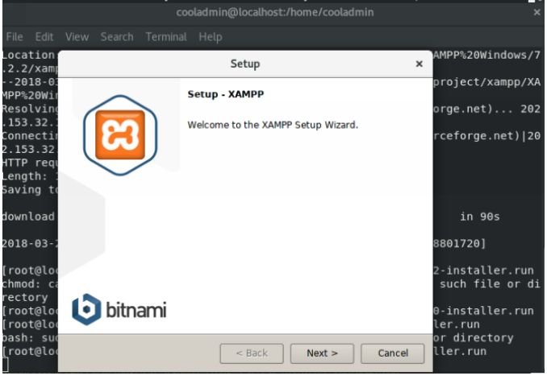
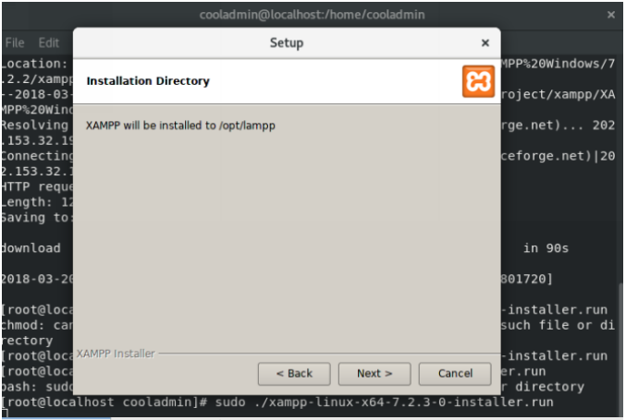
STEP-5:
If everything completes without any issue then Xampp Control Panel will run.
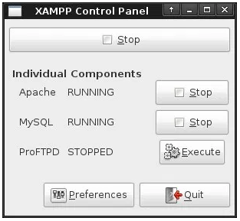

STEP-6:
Now visit official website for documentations and further information
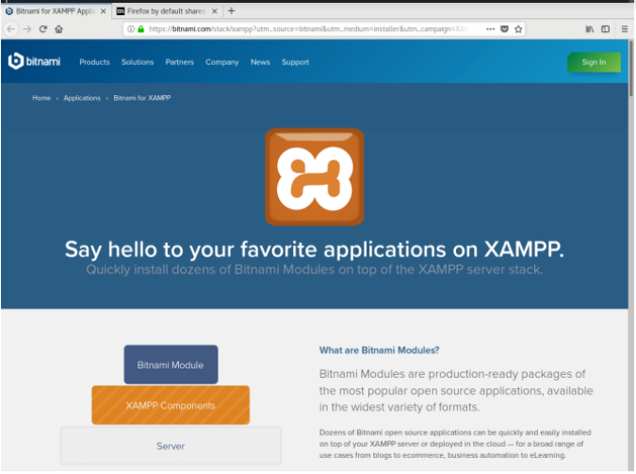

WEEK-3

AIM: Adding CSS and JavaScript to the static Web-page and Introduction to main, header and footer elements of HTML5.

THEORY:
3.1: Cascading Style Sheets (CSS)
Cascading Style Sheets (CSS) is a style sheet language used for describing the presentation of a document written in a markup language. Although most often used to set the visual style of web pages and user interfaces written in HTML and XHTML. Along with HTML and JavaScript.CSS is designed primarily to enable the separation of presentation and content, including aspects such as the layout, colors, and fonts. This separation can improve content accessibility, provide more flexibility and control in the specification of presentation characteristics, enable multiple HTML pages to share formatting by specifying the relevant CSS in a separate .css file, and reduce complexity and repetition in the structural content.
Separation of formatting and content makes it possible to present the same markup page in different styles for different rendering methods, such as on-screen, in print, by voice (via speech-based browser or screen reader), and on Braille-based tactile devices. It can also display the web page differently depending on the screen size or viewing device.
Changes to the graphic design of a document (or hundreds of documents) can be applied quickly and easily, by editing a few lines in the CSS file they use, rather than by changing markup in the documents. The CSS specification describes a priority scheme to determine which style rules apply if more than one rule matches against a particular element. In this so-called cascade, priorities (or weights) are calculated and assigned to rules, so that the results are predictable.

3.1: JavaScript (JS)
JavaScript, often abbreviated as JS, is a high-level, dynamic, weakly typed, object-based, multi-paradigm, and interpreted programming language. Alongside HTML and CSS, JavaScript is one of the three core technologies of World Wide Web content production. It is used to make webpages interactive and provide online programs, including video games. The majority of websites employ it, and all modern web browsers support it by built-in JavaScript engine. Each of the many JavaScript is based on the ECMAScript specification, with some engines not supporting the spec fully, and with many engines supporting additional features beyond ECMA.
As a multi-paradigm language, JavaScript supports event-driven, functional, and imperative (including object-oriented and prototype-based) programming styles. It has an API for working with text, arrays, dates, regular expressions, and basic manipulation of the DOM, but does not include any I/O, such as networking, storage, or graphics facilities, relying for these upon the host environment in which it is embedded.
Initially only implemented client-side in web browsers, JavaScript engines are now embedded in many other types of host software, including server-side in web servers and databases, and in non-web programs such as word processors and PDF software, and in runtime environments that make JavaScript available for writing mobile and desktop applications, including desktop widgets.
Although there are strong outward similarities between JavaScript and Java, including language name, syntax, and respective standard libraries, the two languages are distinct and differ greatly in design; JavaScript was influenced by programming languages such as Self and Scheme.

SOURCE CODE:
index.html:
<!DOCTYPE HTML>
<!DOCTYPE html>
<html>
<head>
<meta charset="UTF-8">
<meta name="viewport" content="width=device-width, initial-scale=1.0">
<meta http-equiv="X-UA-Compatible" content="ie=edge">
<title>Portfolio- Tanmay Sharma</title>
<link rel="stylesheet" type="text/css" href="cssT.css">
</head>
<body>

<div class="header">
<div class="inner-header">
<div class="logo">
<a href="#about">Tanmay Sharma</a>
</div>
<div class="header-link">
<a href="#achievement">Achievements</a>
</div>
<div class="header-link">
<a href="#comp">Competencies</a>
</div>
<div class="header-link">
<a href="#about">About Me</a>
</div>
<div class="header-link">
<a href="#h">Home</a>
</div>
</div>
</div>
<div class="content" id="h">
<div class="banner-image">
<div class="inner-banner-image">
<div class="banner_content">
<h1>Hi, my name is Tanmay.</h1>
<h1>I am <u>Programmer</u> and <u>Python Enthusiast</u>.</h1>
<a href="tel:9013839374" class="button">Call me</a>
</div>
</div>
</div>
<div class="aboute" id="about">
<div class="profile-image">
<img src="bg1.jpg" alt="img" style="border: 1px solid black">
<div class="t">
<h4>Tanmay Sharma</h4>
<p><b>DOB:</b> 21 March 1997</p>
<p><b>Education Qualification:</b> BTech-CSE</p>
<p><b>College:</b> Maharaja Agrasen Institute of Technology</p>
<p><b>Programming Skills:</b> Python, JavaFX, C, C++, Java</p>
</div>
</div>
<div class="about-content" style="padding: 20px;">
<h1 style="text-align: center">ABOUT ME</h1>
<p>Driven CSE student who has keen to pursue future in Machine Learning & Artificial Intelligence.<br>I'm high energy, enthusiastic person, passionate about working hand-in-hand with developers and interested in technology.<br>I am pursuing BTech in the branch of Computer Science & Engineering from Maharaja Agrasen Institute of <br>Technology affiliated to Guru Gobind Singh Indraprastha University.</p>

</div>
</div>
<div class="competencies" id="comp" style="text-align: center">
<br>
<br>
<div>
<h1 style="color: red"><u>COMPETENCIES</u></h1>
<br>
<br>
<table style="width:auto; color: yellow;">
<tr>
<th >Programming Languages & other computer skills</th>
<td>JAVAFX, Python, C, C++, JAVA, SQL, Microsoft Power Point, Microsoft Excel, MS Office, Internet , Photoshop</td>
</tr>
<tr>
<th>Hobbies & Interest</th>
<td>Badminton, Listening Music, finding and reading new technologies and article related to my field and interest</td>
</tr>
<tr>
<th>Strength</th>
<td>Optimistic, Punctuality, Hard Working, Dedicated towards work, Flexible Nature</td>
</tr>
</table>
</div>
<br>
<br>
<br>
<div>
<h1 style="color: red"><u>Project Work</u></h1>
<p style="color: yellow;">Internship in Defence Lab (DRDO), Jodhpur on project <b><u>DIGITAL IMAGE PROCESSING through JavaFX</u></b>. </p>
</div>
</div>
<div class="achievement" id="achievement">
<br>
<br>
<h1 style="text-align: center"><u>ACHIEVEMENTS</u></h1>
<ul>
<li>Cyber Security Certificate by CyberCure Solutions (an unit of CyberCure Technologies Pvt. Ltd) at Delhi Technological University</li>
<li>Code Wars 2 (Programming) certificate by MAIT-CSI.</li>
<li>Won Mathematics award in class XIIth.</li>
<li>Participated in National Student Science Congress at Zonal level, District level and State level.</li>
<li>Judo YELLOW BELTER with Silver medal.</li>
</ul>

</div>
</div>

<footer>
<div>
<center>
<p>
Copyright © HackerTanmay. All Rights Reserved | Contact Us: +91 9013839374
<br><br>
<em>Important: Designed & Developed by <a href="mailto:tanmay.sharma97.ts@gmail.com">U8krs</em>
</p>
</center>
</div>
</footer>
</body>
</html>

style.css:
body{
width: 100%;
height: 100%;
margin: 0;
background-color: grey;
}

a{
text-decoration: none;
background-color: transparent;
color:#ededed;
}

.header{
background-color:#000;
color:#fff;
border-color: #080808;
min-height: 50px;
border: 1px solid transparent;

}

.inner-header{
width:80%;
margin:auto;

}

.logo{
float: left;
height: 50px;
padding: 15px;
font-size: 20px;
font-weight: bold;
}

.header-link{
float:right;
font-size:14px;
height: 50px;
padding: 15px 15px;
font-size:16px;
font-weight: bold;
}

.content{
min-height: 600px;
}

.banner-image{
padding-bottom: 50px;
margin-bottom: 20px;
text-align: center;
color: #f8f8f8;
background: url(intro-bg_1.jpg) no-repeat center;
background-size: cover;
}

.inner-banner-image{
padding-top: 12%;
width:80%;
margin:auto;
}

.banner_content{
position: relative;

padding-top: 6%;
padding-bottom: 6%;
overflow:hidden;
margin-bottom: 12%;
background-color: rgba(0, 0, 0, 0.7);
min-width: 256px;
}

.button{
color: #fff;
background-color: #c9302c;
border-color: #ac2925;
box-shadow: inset 0 3px 5px rgba(0, 0, 0, .125);
padding: 10px 16px;
font-size: 18px;
border-radius: 6px;
}
.aboute{
padding: 50px;
background: url(e.jpg) no-repeat center;
background-size: cover;
overflow:auto;
border: 1px solid black;
}

.about-content{
border: 1px solid black;
}

.t{
text-align: center;
border: 1px solid black;
}
table, th, td {
border: 2px solid green;
padding: 15px;
border-collapse: collapse;
}

@media only screen and (min-width: 480px) {
.button {
visibility: hidden;
}
.profile-image{
float:left;
}
.about-content{
float: left;
}
.header{
position: fixed;
top: 0;
width: 100%;
height: auto;
}
}

.competencies{
clear:both;
padding: 50px;
background: url(2.jpg) no-repeat center;
background-size: cover;
overflow:auto;
border: 1px solid black;
min-height: 600px;
}

.achievement{
clear:both;
padding: 50px;
background: url(r.png) no-repeat center;
background-size: cover;
overflow:auto;
border: 1px solid black;
min-height: 600px;

}

@media only screen and (max-width: 480px) {
img{
width:100%;
}
}

footer{
clear: both;
background-color: #000;
color:#fff;
font-size:14px;
padding: 40px 0px 20px 0px;
}

script.js:
function myFunction() {
var x = document.getElementById("myTopnav");
if (x.className === "topnav") {
x.className += " responsive";
} else {
x.className = "topnav";
}
}

WEEK-4

AIM: Adding Menus and lists to the Web-page.

THEORY:
4.1: HTML <menu> tag
The <menu> tag defines a list/menu of commands.
The <menu> tag is used for context menus, toolbars and for listing form controls and commands.

4.2: HTML lists
HTML supports three kinds of lists namely, ordered list, unordered list and definition list.
An unordered list starts with the <ul> tag. Each list item starts with the <li> tag.
The list items will be marked with bullets (small black circles) by default.
An ordered list starts with the <ol> tag. Each list item starts with the <li> tag.
The list items will be marked with numbers by default.
A description list is a list of terms, with a description of each term.
The <dl> tag defines the description list, the <dt> tag defines the term (name), and the <dd> tag describes each term

SOURCE CODE:
products.html:
<!DOCTYPE HTML>
<!DOCTYPE html>
<html>
<head>
<meta charset="UTF-8">
<meta name="viewport" content="width=device-width, initial-scale=1.0">
<meta http-equiv="X-UA-Compatible" content="ie=edge">
<title>Portfolio- Tanmay Sharma</title>
<link rel="stylesheet" type="text/css" href="cssT.css">
</head>
<body>

<div class="header">
<div class="inner-header">
<div class="logo">
<a href="#about">Tanmay Sharma</a>
</div>
<div class="header-link">
<a href="#achievement">Achievements</a>
</div>
<div class="header-link">
<a href="#comp">Competencies</a>
</div>
<div class="header-link">
<a href="#about">About Me</a>
</div>
<div class="header-link">
<a href="#h">Home</a>
</div>
</div>
</div>
<div class="content" id="h">
<div class="banner-image">
<div class="inner-banner-image">
<div class="banner_content">
<h1>Hi, my name is Tanmay.</h1>
<h1>I am <u>Programmer</u> and <u>Python Enthusiast</u>.</h1>
<a href="tel:9013839374" class="button">Call me</a>
</div>
</div>
</div>
<div class="aboute" id="about">
<div class="profile-image">
<img src="bg1.jpg" alt="img" style="border: 1px solid black">
<div class="t">
<h4>Tanmay Sharma</h4>
<p><b>DOB:</b> 21 March 1997</p>
<p><b>Education Qualification:</b> BTech-CSE</p>
<p><b>College:</b> Maharaja Agrasen Institute of Technology</p>
<p><b>Programming Skills:</b> Python, JavaFX, C, C++, Java</p>
</div>
</div>
<div class="about-content" style="padding: 20px;">
<h1 style="text-align: center">ABOUT ME</h1>
<p>Driven CSE student who has keen to pursue future in Machine Learning & Artificial Intelligence.<br>I'm high energy, enthusiastic person, passionate about working hand-in-hand with developers and interested in technology.<br>I am pursuing BTech in the branch of Computer Science & Engineering from Maharaja Agrasen Institute of <br>Technology affiliated to Guru Gobind Singh Indraprastha University.</p>

</div>
</div>
<div class="competencies" id="comp" style="text-align: center">
<br>
<br>
<div>
<h1 style="color: red"><u>COMPETENCIES</u></h1>
<br>
<br>
<table style="width:auto; color: yellow;">
<tr>
<th >Programming Languages & other computer skills</th>
<td>JAVAFX, Python, C, C++, JAVA, SQL, Microsoft Power Point, Microsoft Excel, MS Office, Internet , Photoshop</td>
</tr>
<tr>
<th>Hobbies & Interest</th>
<td>Badminton, Listening Music, finding and reading new technologies and article related to my field and interest</td>
</tr>
<tr>
<th>Strength</th>
<td>Optimistic, Punctuality, Hard Working, Dedicated towards work, Flexible Nature</td>
</tr>
</table>
</div>
<br>
<br>
<br>
<div>
<h1 style="color: red"><u>Project Work</u></h1>
<p style="color: yellow;">Internship in Defence Lab (DRDO), Jodhpur on project <b><u>DIGITAL IMAGE PROCESSING through JavaFX</u></b>. </p>
</div>
</div>
<div class="achievement" id="achievement">
<br>
<br>
<h1 style="text-align: center"><u>ACHIEVEMENTS</u></h1>
<ul>
<li>Cyber Security Certificate by CyberCure Solutions (an unit of CyberCure Technologies Pvt. Ltd) at Delhi Technological University</li>
<li>Code Wars 2 (Programming) certificate by MAIT-CSI.</li>
<li>Won Mathematics award in class XIIth.</li>
<li>Participated in National Student Science Congress at Zonal level, District level and State level.</li>
<li>Judo YELLOW BELTER with Silver medal.</li>
</ul>

</div>
</div>

<footer>
<div>
<center>
<p>
Copyright © HackerTanmay. All Rights Reserved | Contact Us: +91 9013839374
<br><br>
<em>Important: Designed & Developed by <a href="mailto:tanmay.sharma97.ts@gmail.com">U8krs</em>
</p>
</center>
</div>
</footer>
</body>
</html>
Scrrenshot:
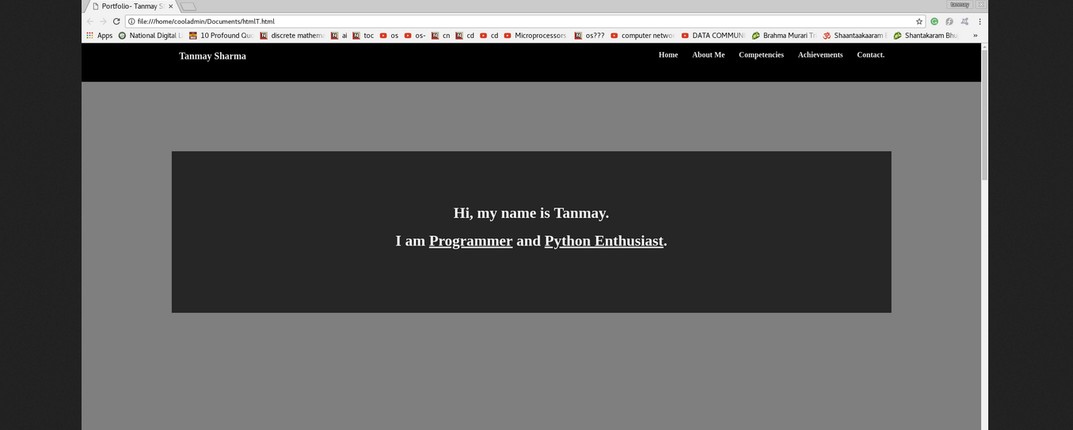

WEEK-5

AIM: Developing forms for the website.

THEORY:
5.1: The <form> Element
The HTML <form> element defines a form that is used to collect user input. An HTML form contains form elements.
Form elements are different types of input elements, like text fields, checkboxes, radio buttons, submit buttons, and more.

5.2: The <input> Element
The <input> element is the most important form element.
The <input> element can be displayed in several ways, depending on the type attribute.
Here are some examples:
Type | Description
<input type="text"> | Defines a one-line text input field
<input type="radio"> | Defines a radio button (for selecting one of many choices)
<input type="submit"> | Defines a submit button (for submitting the form)

SOURCE CODE:
login.html:
<!DOCTYPE html>
<html lang="en">
<head>
<meta charset="UTF-8">
<meta name="viewport" content="width=device-width, initial-scale=1.0">
<meta http-equiv="X-UA-Compatible" content="ie=edge">
<title> Form-Contact </title>
<link href="style.css" rel="stylesheet" type="text/css"/>
<script src="js/scripts.js"></script>
</head>
<body>
<br><br><br>

<center style="vertical-align: center;">
<br>
<b><h1 style="color: blue;">Contact info</h1></b>
<form name="myForm" class="form" action="conf.jsp" method="post">
<div class="form-group">
First Name: <input type="text" name="firstname" id="firstname" class="form-control" placeholder="First Name">
<br> <br>
</div>
<div class="form-group">
Last Name: <input type="text" name="lastname" id="lastname" class="form-control" placeholder="Last Name">
<br> <br>
</div>
<div class="form-group">
Email id: <input type="Email" name="email" id="email" class="form-control" placeholder=" Email Id">
<br> <br>
</div>
<div class="form-group">
<br> Gender:
<select name="gender">
<option>Male</option>
<option>Female</option>
<option>Other</option>
</select>
<br>
<br>
</div>

<div class="form-group">
Contact Number: <input type="text" name="contact" id="contact" class="form-control" placeholder=" Contact">
</div>
<center><button type="submit" class="btn btn-primary" name="submit">Submit</button></center>
</form>

</center>
<footer style="position: absolute; bottom: 0; width: 100%;">
<div>
<center>
<p>
Copyright © TS. All Rights Reserved <br> Contact Us: <a href="tel:+91 9013839374">+91 9013839374</a><br>Designed & Developed by <a href="mailto:tanmay.sharma97.ts@gmail.com">ts</a>
</p>
</center>
</div>
</footer>
<script>
function validateForm() {
var x = document.forms["myForm"]["firstname"].value;
if (x == "") {
alert("Name must be filled out");
return false;
}
}

var stre = document.forms["myForm"]["email"].value;
if (!(stre.match(/^\w+([\.-]?\w+)*@\w+([\.-]?\w+)*(\.\w{2,3})+$/))) {
alert("Invalid email-id");
return false;
}

</script>
</body>
</html>
screenshot:
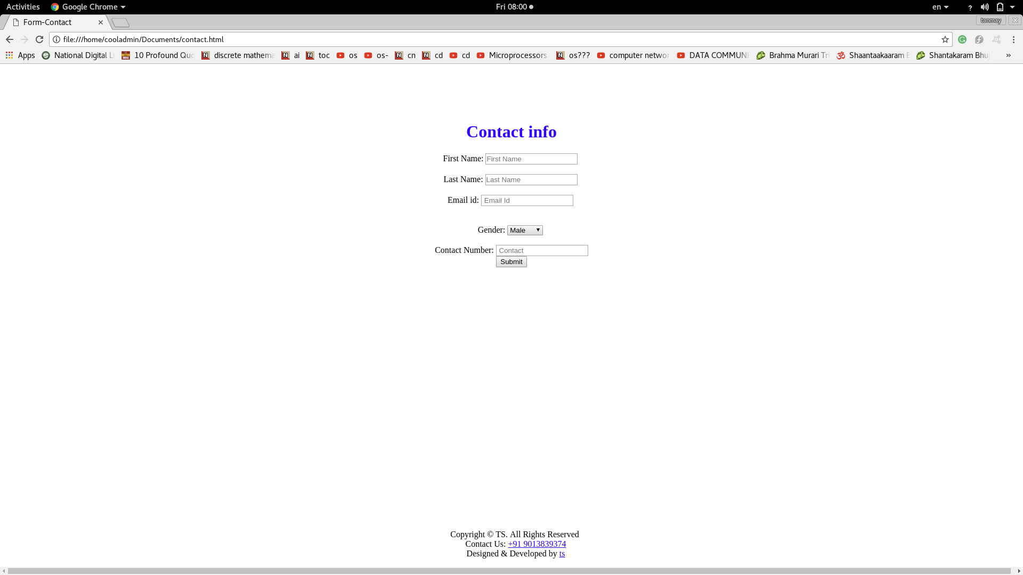

WEEK-6

AIM: Adding JSP to HTML forms.

THEORY:
6.1: JAVA Server Pages (JSP)
JavaServer Pages (JSP) is a technology for developing Webpages that supports dynamic content.
This helps developers insert java code in HTML pages by making use of special JSP tags, most of
which start with <% and end with %>.
A JavaServer Pages component is a type of Java servlet that is designed to fulfill the role of a user
interface for a Java web application. Web developers write JSPs as text files that combine HTML or
XHTML code, XML elements, and embedded JSP actions and commands.
Using JSP, you can collect input from users through Webpage forms, present records from a
database or another source, and create Webpages dynamically.
JSP tags can be used for a variety of purposes, such as retrieving information from a database or
registering user preferences, accessing JavaBeans components, passing control between pages, and
sharing information between requests, pages etc.

6.2: Why Use JSP?
JavaServer Pages often serve the same purpose as programs implemented using the Common
Gateway Interface (CGI). But JSP offers several advantages in comparison with the CGI.
• Performance is significantly better because JSP allows embedding Dynamic Elements in
HTML Pages itself instead of having separate CGI files.
• JSP are always compiled before they are processed by the server unlike CGI/Perl which
requires the server to load an interpreter and the target script each time the page is requested.
• JavaServer Pages are built on top of the Java Servlets API, so like Servlets, JSP also has
access to all the powerful Enterprise Java APIs, including JDBC, JNDI, EJB, JAXP, etc.
• JSP pages can be used in combination with servlets that handle the business logic, the model
supported by Java servlet template engines.
SOURCE CODE:
form_action.jsp

<%@page import="java.sql.ResultSet"%>
<%@page import="java.sql.Statement"%>
<%@page import="java.sql.DriverManager"%>
<%@page import="java.sql.Connection"%>
<html>
<body>
<%
String First = request.getParameter("firstname");
String Last = request.getParameter("lastname");
String Email = request.getParameter("email");
String Gender= request.getParameter("gender");
String Contact= request.getParameter("contact");
Statement st=null;
try{
Class.forName("com.mysql.jdbc.Driver");
Connection con=DriverManager.getConnection("jdbc:mysql://localhost:3306/Web","root","");
st=con.createStatement();

st.executeUpdate("insert into form1 (first,last,email,gender,contact)values('"+First+"','"+Last+"','"+Email+"','"+Gender+"','"+Contact+"')");
out.println("Data Inserted Successfully!!!");
}catch(Exception e){
out.println(e);

}
ResultSet resultSet = null;
%>
<h2 align="center"><font><strong>Retrieve data from database in JSP</strong></font></h2>
<table align="center" cellpadding="5" cellspacing="5" border="1">
<tr>

</tr>
<tr bgcolor="#A52A2A">
<td><b>First Name</b></td>
<td><b>Last Name</b></td>
<td><b>Email</b></td>
<td><b>Gender</b></td>
<td><b>Contact No.</b></td>
</tr>
<%
try{
String sql ="SELECT * FROM form1";

resultSet = st.executeQuery(sql);
while(resultSet.next()){
%>
<tr bgcolor="#DEB887">

<td><%=resultSet.getString("first") %></td>
<td><%=resultSet.getString("last") %></td>
<td><%=resultSet.getString("email") %></td>
<td><%=resultSet.getString("gender") %></td>
<td><%=resultSet.getString("contact") %></td>

</tr>

<%
}

} catch (Exception e) {
e.printStackTrace();
}
%>
</table>

</body>
Screenshot:


WEEK-7(a)

AIM: Adding Validations to HTML forms

THEORY:
7.1: JavaScript Form Validation
HTML form validation can be done by JavaScript.
If a form field (fname) is empty, this function alerts a message, and returns false, to prevent the form from being submitted.

7.2: Automatic HTML validations
HTML form validation can be performed automatically by the browser:
If a form field (fname) is empty, the required attribute prevents this form from being submitted. Automatic HTML form validation does not work in Internet Explorer 9 or earlier.

SOURCE CODE:
Signup.html:
<!DOCTYPE html>
<html lang="en">
<head>
<meta charset="UTF-8">
<meta name="viewport" content="width=device-width, initial-scale=1.0">
<meta http-equiv="X-UA-Compatible" content="ie=edge">
<title> Form-Contact </title>
<link href="style.css" rel="stylesheet" type="text/css"/>
<script src="js/scripts.js"></script>
</head>
<body>
<br><br><br>

<center style="vertical-align: center;">
<br>
<b><h1 style="color: blue;">Contact info</h1></b>
<form name="myForm" class="form" action="conf.jsp" method="post">
<div class="form-group">
First Name: <input type="text" name="firstname" id="firstname" class="form-control" placeholder="First Name">
<br> <br>
</div>
<div class="form-group">
Last Name: <input type="text" name="lastname" id="lastname" class="form-control" placeholder="Last Name">
<br> <br>
</div>
<div class="form-group">
Email id: <input type="Email" name="email" id="email" class="form-control" placeholder=" Email Id">
<br> <br>
</div>
<div class="form-group">
<br> Gender:
<select name="gender">
<option>Male</option>
<option>Female</option>
<option>Other</option>
</select>
<br>
<br>
</div>

<div class="form-group">
Contact Number: <input type="text" name="contact" id="contact" class="form-control" placeholder=" Contact">
</div>
<center><button type="submit" class="btn btn-primary" name="submit">Submit</button></center>
</form>

</center>
<footer style="position: absolute; bottom: 0; width: 100%;">
<div>
<center>
<p>
Copyright © TS. All Rights Reserved <br> Contact Us: <a href="tel:+91 9013839374">+91 9013839374</a><br>Designed & Developed by <a href="mailto:tanmay.sharma97.ts@gmail.com">ts</a>
</p>
</center>
</div>
</footer>
<script>
function validateForm() {
var x = document.forms["myForm"]["firstname"].value;
if (x == "") {
alert("Name must be filled out");
return false;
}
}

var stre = document.forms["myForm"]["email"].value;
if (!(stre.match(/^\w+([\.-]?\w+)*@\w+([\.-]?\w+)*(\.\w{2,3})+$/))) {
alert("Invalid email-id");
return false;
}

</script>
</body>
</html>
Screenshot:

WEEK-7(b)

AIM: Adding date and time to HTML forms

THEORY:
7.1: JavaScript Date Formats
A JavaScript date can be written as a string: Fri Apr 06 2018 00:04:34 GMT+0530 (India Standard Time)
or as a number:1522953274257
Dates written as numbers, specifiy the number of milliseconds since January 1, 1970, 00:00:00.

7.2: Creating Date Objects
The Date object lets us work with dates.
A date consists of a year, a month, a day, an hour, a minute, a second, and milliseconds.
Date objects are created with the new Date() constructor.
There are 4 ways of initiating a date:
new Date()
new Date(milliseconds)
new Date(dateString)
new Date(year, month, day, hours, minutes, seconds, milliseconds)
Using new Date(), creates a new date object with the current date and time.

SOURCE CODE:
Signup.html:
<!DOCTYPE html>
<html lang="en">
<head>
<script>
var d = new Date();
document.getElementById("demo").innerHTML = d;
</script>
<meta charset="UTF-8">
<meta name="viewport" content="width=device-width, initial-scale=1.0">
<meta http-equiv="X-UA-Compatible" content="ie=edge">
<title> Form-Contact </title>
<link href="style.css" rel="stylesheet" type="text/css"/>
<script src="js/scripts.js"></script>
</head>
<body>
<div>
<p id="demo"></p>
</div>
<br><br><br>

<center style="vertical-align: center;">
<br>
<b><h1 style="color: blue;">Contact info</h1></b>
<form name="myForm" class="form" action="conf.jsp" method="post">
<div class="form-group">
First Name: <input type="text" name="firstname" id="firstname" class="form-control" placeholder="First Name">
<br> <br>
</div>
<div class="form-group">
Last Name: <input type="text" name="lastname" id="lastname" class="form-control" placeholder="Last Name">
<br> <br>
</div>
<div class="form-group">
Email id: <input type="Email" name="email" id="email" class="form-control" placeholder=" Email Id">
<br> <br>
</div>
<div class="form-group">
<br> Gender:
<select name="gender">
<option>Male</option>
<option>Female</option>
<option>Other</option>
</select>
<br>
<br>
</div>

<div class="form-group">
Contact Number: <input type="text" name="contact" id="contact" class="form-control" placeholder=" Contact">
</div>
<center><button type="submit" class="btn btn-primary" name="submit">Submit</button></center>
</form>

</center>
<footer style="position: absolute; bottom: 0; width: 100%;">
<div>
<center>
<p>
Copyright © TS. All Rights Reserved <br> Contact Us: <a href="tel:+91 9013839374">+91 9013839374</a><br>Designed & Developed by <a href="mailto:tanmay.sharma97.ts@gmail.com">ts</a>
</p>
</center>
</div>
</footer>
<script>
function validateForm() {
var x = document.forms["myForm"]["firstname"].value;
if (x == "") {
alert("Name must be filled out");
return false;
}
}

var stre = document.forms["myForm"]["email"].value;
if (!(stre.match(/^\w+([\.-]?\w+)*@\w+([\.-]?\w+)*(\.\w{2,3})+$/))) {
alert("Invalid email-id");
return false;
}

</script>
</body>
</html>
Scrrenshots:
